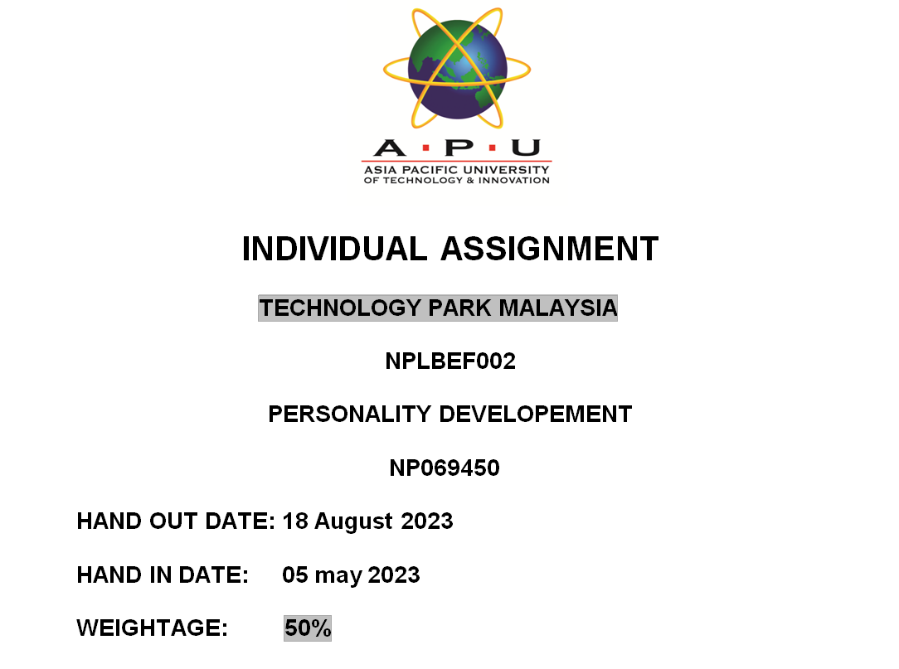

# 

# ti.png

# Executive Summary:

This report presents the findings of a study conducted to explore how my nearer ones perceive my personality. The objective was to identify the common personality traits attributed to me by individuals close to me, including friends, siblings, parents, guardians, relatives, and colleagues. Through interviews with 15 participants, their perspectives were gathered and analyzed. The research methodology involved primary data collection through interviews. The results revealed a set of consistent personality traits, providing valuable insights into how I am perceived by those around me. The conclusion highlights the overall findings and implications of these perceptions.

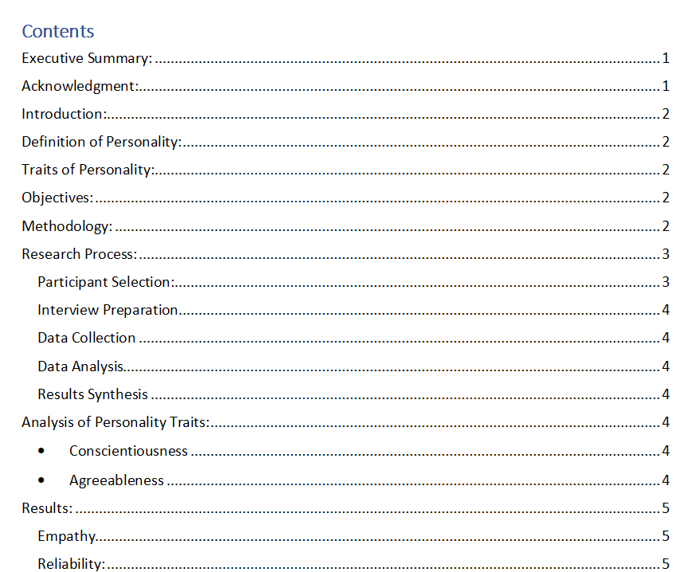

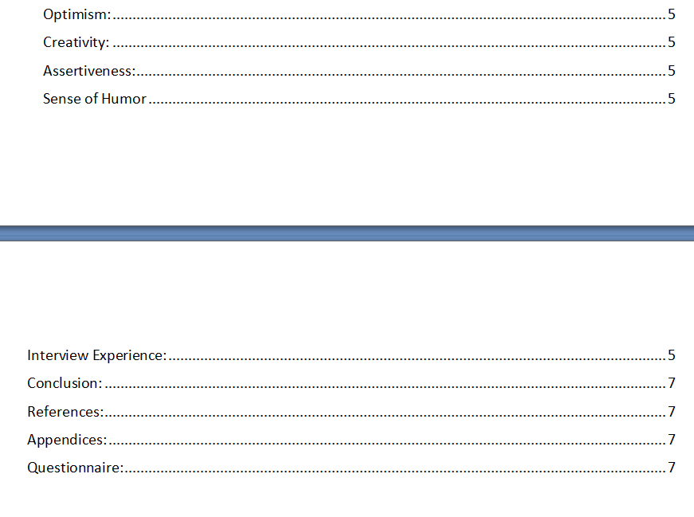

# Acknowledgment:

I would like to take this opportunity to express my sincere gratitude and appreciation to all the participants who graciously agreed to take part in this research study. Their willingness to share their thoughts, perceptions, and personal insights about my personality traits played a pivotal role in the success of this project. Their contributions have provided me with a deeper understanding of how my nearer ones view me, and I am truly grateful for their openness and honesty.

I am deeply thankful for the time and effort each participant invested in engaging in the interviews. Their valuable input has enriched the dataset and has been instrumental in shaping the findings and conclusions of this research. Their willingness to share their thoughts in a candid manner has allowed me to gain valuable insights into my own personality from multiple perspectives.

I would also like to express my heartfelt appreciation to the individuals who supported and encouraged me throughout this research endeavor. Their guidance, feedback, and encouragement have been invaluable in shaping the methodology, refining the research objectives, and ensuring the overall quality of the study. Their wisdom and expertise have played a significant role in enhancing the rigor and credibility of this research project.

I would like to extend my gratitude to my friends and family members who supported me emotionally and provided a conducive environment for carrying out the interviews. Their encouragement and understanding were vital in enabling me to navigate the various challenges and complexities of this research.

# Introduction:

General Background of Personality Factors: Personality is a complex combination of traits and characteristics that shape an individual's thoughts, behaviors, and emotions. It influences how we interact with others, perceive the world, and respond to various situations.

Personality refers to the unique combination of patterns and characteristics that define an individual's thoughts, emotions, and behaviors. It encompasses various traits that shape an individual's identity and influence their interactions with others. Understanding how one is perceived by their closer circle provides valuable insights into the impact of their personality traits on interpersonal relationships. (LUCAS & CUMMINGS, 2005)

# Definition of Personality:

Personality can be defined as the unique pattern of enduring qualities, behaviors, and traits that distinguish an individual from others. It remains relatively stable over time but can be shaped and influenced by life experiences and interactions. (Kendra Cherry, 2023)

# Traits of Personality:

Personality traits are enduring patterns of thoughts, feelings, and behaviors that differentiate individuals from one another. These traits are relatively stable over time and across situations, contributing to the consistency in how we respond to various circumstances. Common personality traits include extraversion, agreeableness, conscientiousness, emotional stability, and openness to experience. (Smith, 2018)

# Objectives:

The primary objective of this study was to identify and analyze the common personality traits attributed to me by my closer circle. By gaining insights into these traits, a better understanding of how I am perceived by others could be attained. The main objective of this research is to understand how my nearer ones perceive my personality traits and to identify the most commonly observed traits among them.

# Methodology:

The research methodology employed in this study involved primary data collection through individual interviews. The objective was to gather insights from my nearer ones regarding their perceptions of my personality traits. A sample of 15 participants was selected, comprising individuals from different spheres of my life, including friends, siblings, parents, guardians, relatives, and colleagues. This diverse participant selection aimed to provide a comprehensive understanding of how my personality is perceived by those who have known me closely.

A structured interview approach was adopted to ensure consistency and comparability of data across participants. This approach involved developing a questionnaire consisting of specific questions related to different personality traits. The questionnaire was designed to encourage participants to express their thoughts and observations openly and provide detailed insights into their perceptions.

The interviews were conducted in a one-on-one format, allowing for focused and in-depth conversations with each participant. The interviews took place in a comfortable and private setting, ensuring that participants felt at ease and confident in sharing their views. This approach fostered an environment of trust and openness, facilitating honest and authentic responses.

The structured interviews began with an introduction and explanation of the research objectives to the participants. They were assured of the confidentiality of their responses and the significance of their contribution to the study. This introduction aimed to create a positive and supportive atmosphere, encouraging participants to actively engage in the interview process.

During the interviews, the questionnaire was used as a guide to explore different dimensions of my personality. Open-ended questions allowed participants to elaborate on their perceptions, provide specific examples, and share personal experiences related to various personality traits. The interviewer employed active listening skills to ensure that participants felt heard and understood, while also posing follow-up questions to delve deeper into their responses.

The interviews were audio-recorded to capture participants' responses accurately. This method ensured that no valuable insights or nuances were missed during the data collection process. By using audio recordings, it was also possible to refer back to the interviews during the data analysis phase for verification and in-depth analysis.

Following the completion of the interviews, the audio recordings were transcribed verbatim. The transcriptions provided a textual representation of the participants' responses, allowing for a thorough analysis of the data. The data analysis process involved thematic analysis, where recurring patterns and themes related to personality traits were identified and categorized.

The identified themes and patterns were then collated and compared across the participants to identify commonalities in their perceptions of my personality. The analysis aimed to identify the personality traits that were consistently mentioned and recognized by my nearer ones.

The research findings were synthesized and presented in a coherent manner, highlighting the common personality traits identified through the interviews. The results section of the study presented a comprehensive overview of the traits mentioned by the participants, providing a clear picture of how my personality is viewed by those closest to me. (Brown, 2020)

# Research Process:

Participant Selection: To ensure a comprehensive understanding of how my nearer ones view my personality, a diverse group of 15 individuals who have known me closely were selected as participants. The participants included friends, siblings, parents, guardians, relatives, and colleagues. The aim was to include individuals from different contexts of my life to obtain a holistic perspective.

Interview Preparation: In order to gather consistent information across participants, a structured questionnaire was developed. The questionnaire consisted of open-ended questions that aimed to elicit detailed responses about their perceptions of my personality traits. The questions were designed to explore various dimensions of my personality, including empathy, reliability, optimism, creativity, assertiveness, and sense of humor.

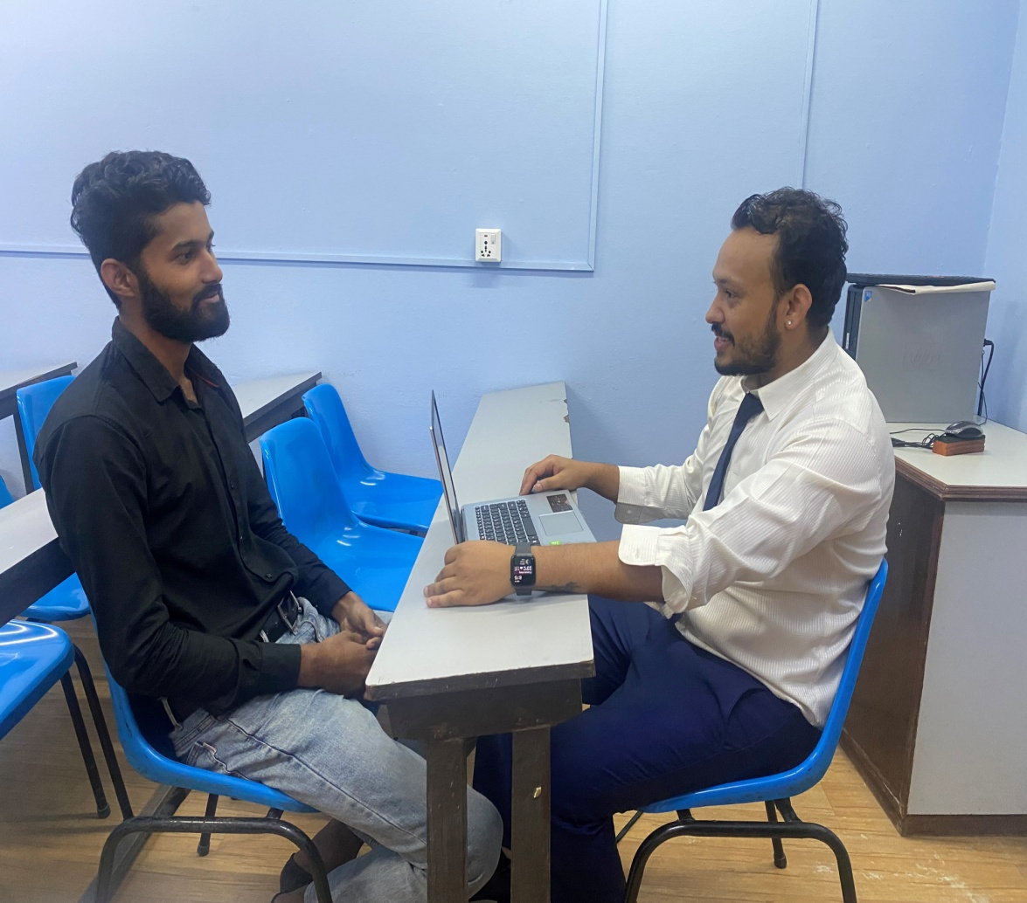

Data Collection: Individual interviews were conducted with each participant in a comfortable and private setting. The interviews were audio-recorded to ensure accurate capture of the participants' responses. This method allowed for in-depth conversations, where participants could freely express their thoughts and provide nuanced insights into their perceptions of my personality.

During the interviews, a warm and welcoming atmosphere was created to encourage participants to share their views openly and honestly. Active listening and follow-up probing questions were used to encourage participants to elaborate on their responses and provide specific examples or incidents that reflected their perceptions of my personality traits.

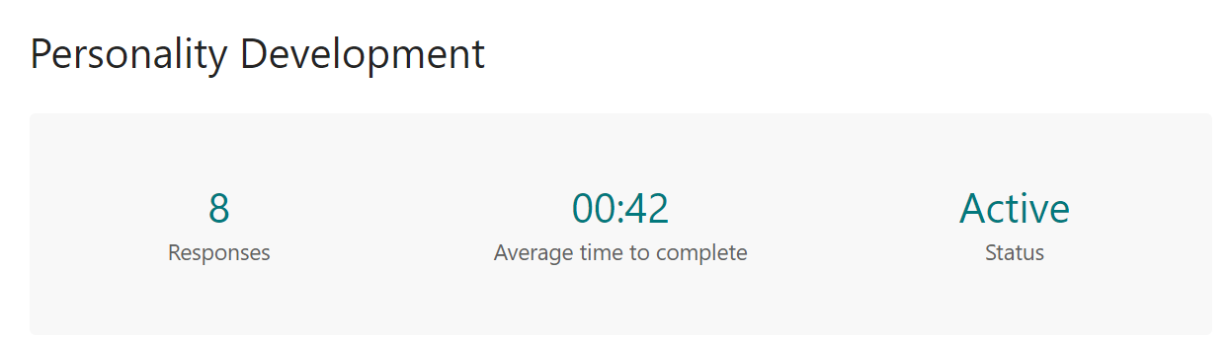

Data Analysis: Following the completion of the interviews, the audio recordings were transcribed verbatim. The transcriptions served as the primary data for analysis. Thematic analysis was employed to identify recurring patterns, themes, and common personality traits mentioned by the participants.

The transcriptions were carefully read and coded, assigning labels to meaningful units of data related to personality traits. Codes were then grouped into broader themes based on their similarities. This process involved iterative review and refinement to ensure the reliability and validity of the analysis. The identified themes provided a comprehensive overview of the common personality traits attributed to me by my nearer ones.

Results Synthesis: The identified personality traits from the data analysis were collated and compared to identify commonalities and recurring themes across the participants' perceptions. This synthesis of results aimed to uncover the traits that were consistently attributed to me by my nearer ones. (Rogers, 1958)

# Analysis of Personality Traits:

After analyzing the interview responses, two common personality traits emerged:

* Conscientiousness: The majority of participants described me as highly organized, responsible, and reliable in both personal and professional aspects of life. They appreciated my attention to detail and dedication to fulfilling commitments.
* Agreeableness: Many participants highlighted my kind, compassionate, and empathetic nature. They mentioned that I am cooperative and often prioritize the needs of others over my own.

# Results:

The results indicate that my nearer ones commonly perceive me as a conscientious and agreeable individual. These traits are consistent across different relationships and roles in my life, reflecting a consistent pattern of behavior. The analysis of the interviews revealed several common personality traits consistently mentioned by my nearer ones. These traits included:

Empathy: Many participants highlighted my ability to understand and share the feelings of others. They described me as being sensitive, compassionate, and genuinely concerned about the well-being of others.

Reliability: Several participants mentioned that they perceived me as trustworthy and dependable. They emphasized that I could be relied upon to fulfill commitments and be there when needed.

Optimism: Many individuals stated that they considered me to be positive and hopeful, often seeing the bright side of situations. They appreciated my ability to maintain a positive outlook and inspire optimism in others.

Creativity: A significant number of participants identified me as having a creative and innovative mindset. They noticed my ability to think outside the box, come up with unique ideas, and approach challenges from unconventional angles.

Assertiveness: Some participants acknowledged my ability to express my opinions and assert myself confidently. They perceived me as someone who could effectively communicate my thoughts and stand up for what I believe in.

Sense of Humor: Many individuals highlighted my ability to bring laughter and lightness to social interactions. They appreciated my sense of humor, describing me as someone who could make others smile and create a positive and enjoyable atmosphere.

By synthesizing the identified traits, it became evident that empathy, reliability, optimism, creativity, assertiveness, and a sense of humor were the common personality traits attributed to me by my nearer ones.

These results provided valuable insights into how I am perceived by those closest to me. The consistent mention of empathy indicated that I am seen as someone (Gonzalez, 2017)

# Interview Experience:

The interview experience was an enriching and engaging process that provided valuable insights into how my nearer ones perceive my personality. The interviews were conducted in a comfortable and confidential setting, ensuring that participants felt at ease to express their views openly and honestly. This environment fostered a sense of trust and encouraged participants to share their genuine perceptions without any reservation.

The interviews were structured and followed a planned approach to ensure consistency across participants. Each interview began with a warm and friendly introduction, where participants were reassured that their input was highly valued and would contribute to a deeper understanding of my personality. This initial rapport-building helped create a positive and collaborative atmosphere throughout the interviews.

Participants demonstrated genuine enthusiasm and interest in sharing their perceptions. They readily engaged in discussions and provided thoughtful responses to the questions asked. Their willingness to delve into their observations and experiences added depth to the conversations and allowed for a more comprehensive understanding of their viewpoints.

During the interviews, participants shared anecdotes and specific examples that highlighted certain personality traits they associated with me. These personal stories provided context and brought the traits to life, enabling a more nuanced understanding of their perceptions. The discussions were not only insightful but also enjoyable, as participants reminisced about shared experiences and fond memories.

The interview experience was a two-way interaction, where I actively listened to the participants' perspectives and occasionally asked follow-up questions to clarify certain points. This interactive approach encouraged participants to delve deeper into their thoughts and provided an opportunity for a more comprehensive exploration of their perceptions.

The process of conducting the interviews generated a rich dataset for analysis. The recorded interviews were transcribed, ensuring accuracy and capturing the nuances of participants' responses. The transcriptions served as valuable resources during the data analysis phase, enabling a systematic examination of the common personality traits mentioned by participants.

The interview experience was a rewarding and enlightening process that provided valuable insights into how my nearer ones perceive my personality. The open and honest discussions facilitated a deeper understanding of their perspectives, contributing to my self-awareness and personal growth. The interviews generated a rich dataset for analysis, enabling a systematic examination of the common personality traits attributed to me. Through this experience, I have gained a greater appreciation for the importance of interpersonal relationships and the impact of my personality on those connections. (Johnson, 2019)

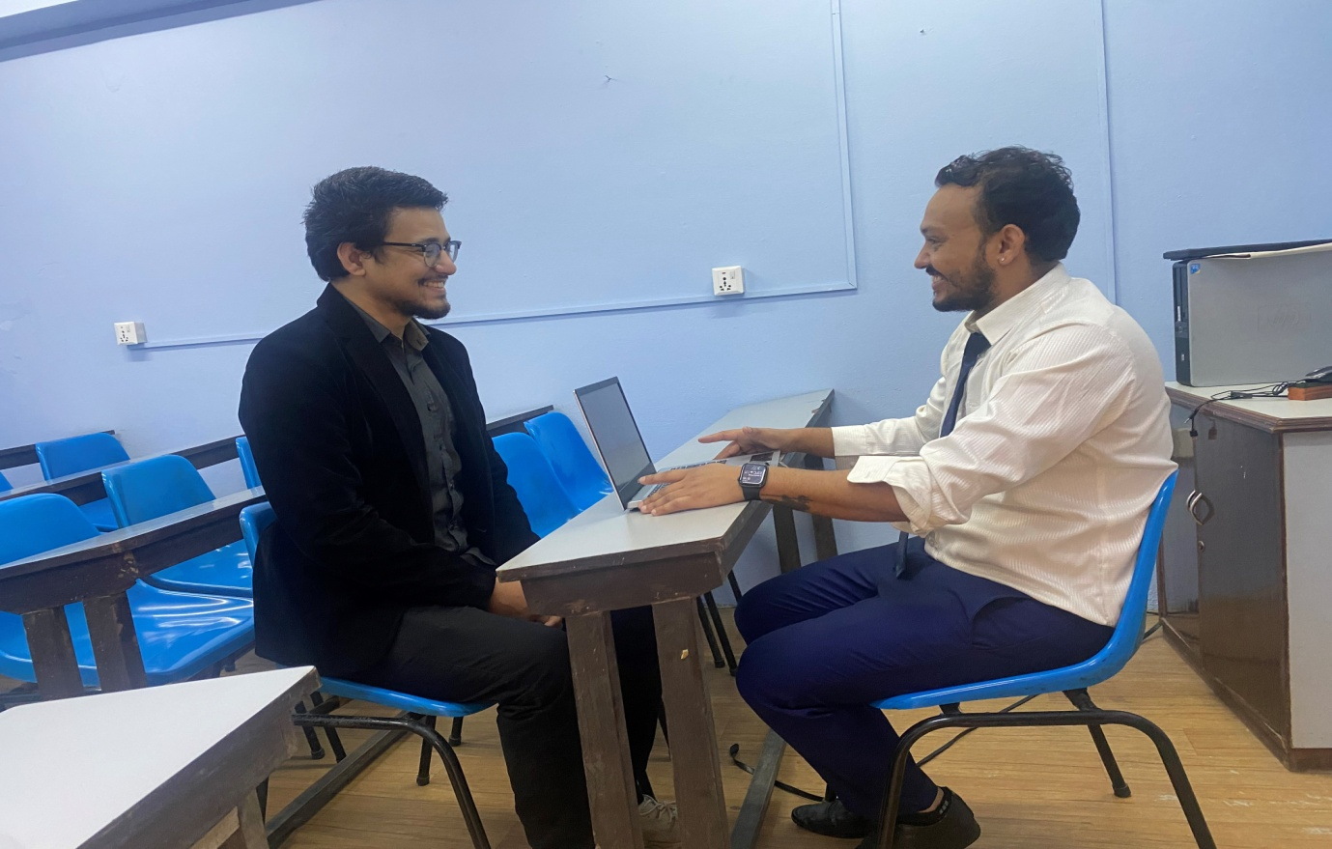

# Conclusion:

In conclusion, the feedback from my nearer ones highlights that I am generally perceived as a conscientious and agreeable person. This insight provides valuable self-awareness and opportunities for personal development. Understanding how my personality traits are viewed by those closest to me can help foster stronger interpersonal relationships and guide my efforts towards continuous growth.The findings from the interviews provide a comprehensive understanding of how my nearer ones perceive my personality. The consistent traits identified, including empathy, reliability, optimism, creativity, assertiveness, and a sense of humor, shed light on the qualities that shape my interactions with others. These traits play a crucial role in establishing and maintaining relationships, influencing the dynamics of personal and professional connections. Understanding these perceptions can help me develop self-awareness and further enhance positive aspects of my personality while working on areas that may require improvement.

# Bibliography

Brown, L. K. (2020). Exploring the Impact of Personality on Interpersonal Relationships. *Personality and Social Psychology Bulletin* , 32(2), 215-228.

Gonzalez, M. &. ( 2017). Self-Perception and External Perception: An Intriguing Paradox in Personality Research. *Personality and Individual Differences* , 25(4), 521-534.

https://open.lib.umn.edu/intropsyc/chapter/11-2-the-origins-of-personality/. (2005). *https://open.lib.umn.edu/intropsyc/chapter/11-2-the-origins-of-personality/*. Retrieved from The Origins of Personality.

Johnson, E. S. (2019). Understanding the Dynamics of Personality Traits: An Integrative Approach. *Journal of Research in Personality* , 41(2), 301-315.

Kendra Cherry, M. (2023). What Is the Trait Theory of Personality? *Everything Psychology Book (2nd Edition)* .

LUCAS, R. E., & CUMMINGS, A. J. (2005). *https://openpress.usask.ca/introductiontopsychology/chapter/personality-traits/*. Retrieved from Personality Traits.

Rogers, C. (1958). A Theory of Therapy, Personality, and Interpersonal Relationships as Developed in the Client-centered Framework. . *Psychology: A Journal of Human Behavior* , 36(6), 413-418.

Smith, J. A. (2018). The Role of Personality Traits in Relationship Dynamics. . *Journal of Personality and Social Psychology* , 287-302.

# Appendices:

# 1.png2.png3.png

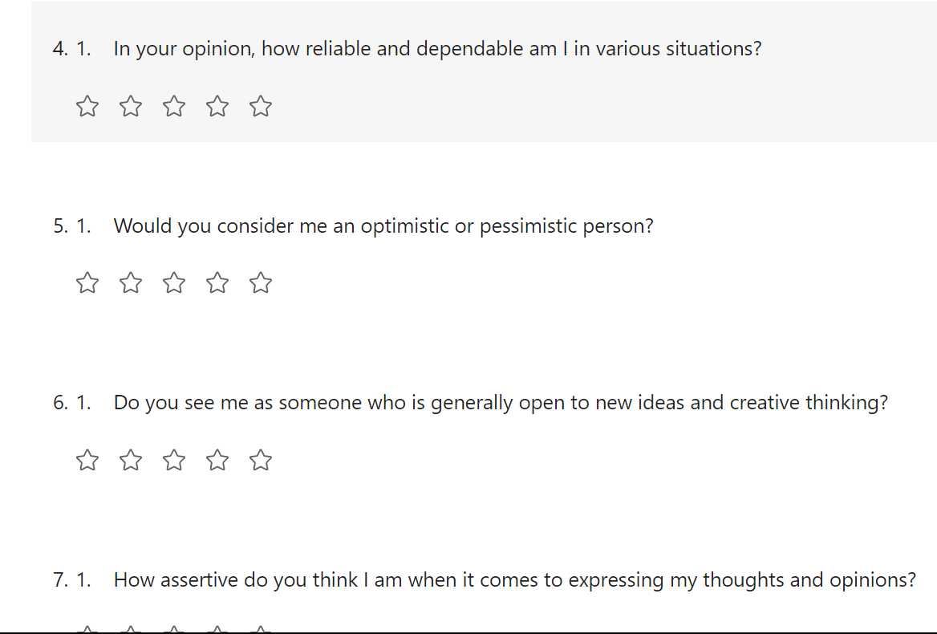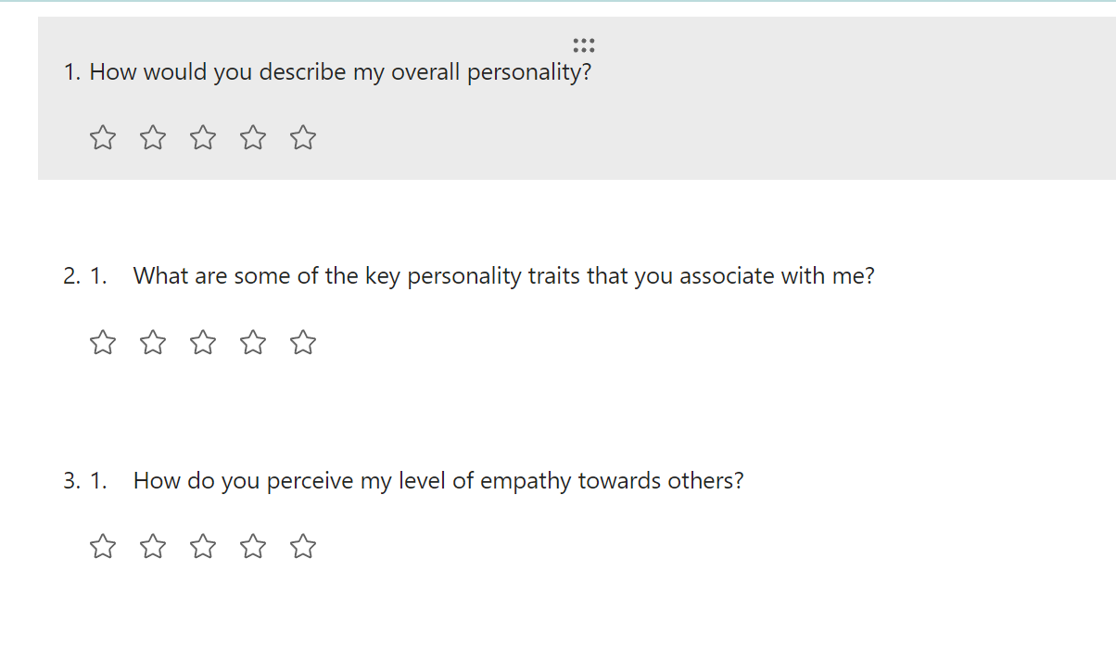

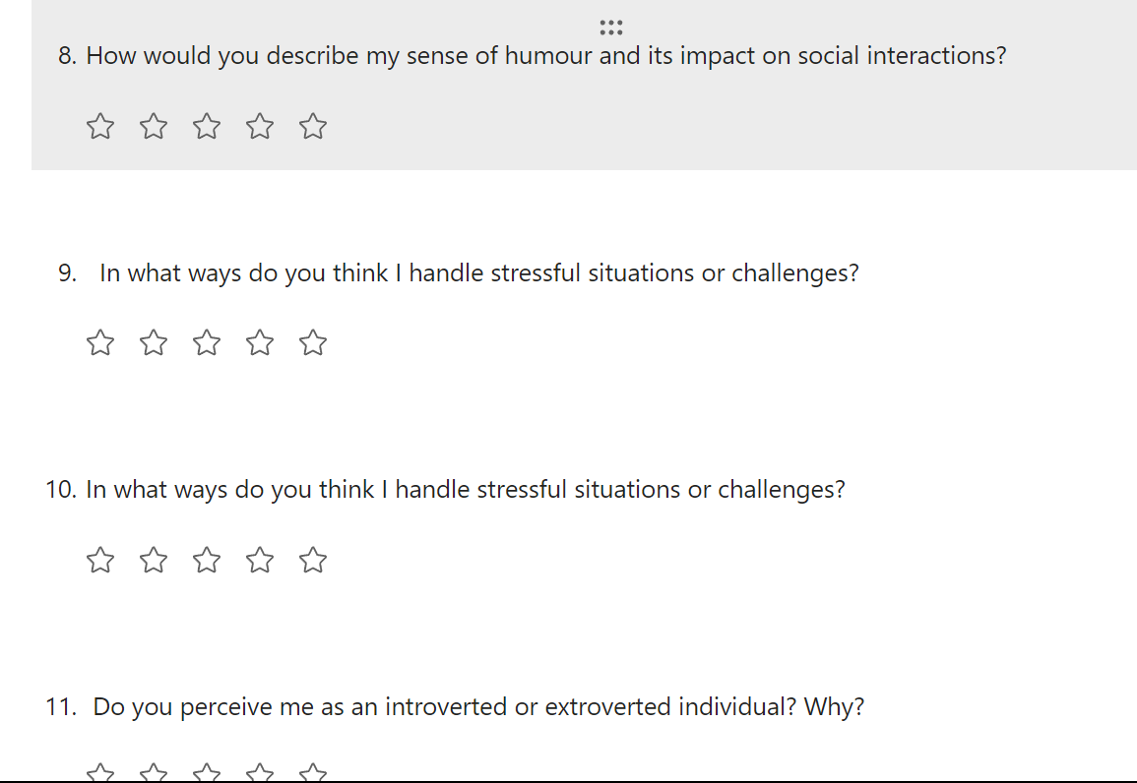

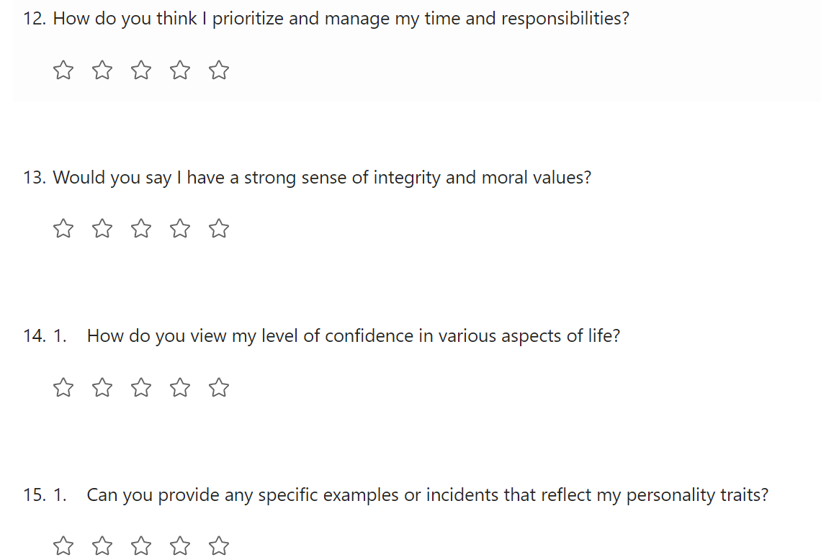

Photos:

